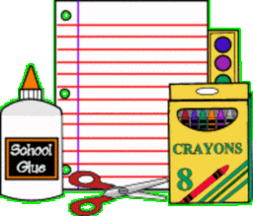

ACA Elementary 2015-2016 School Supply List
Pre-Kindergarten

FULL size backpack (No rolling backpacks)
1 plastic school box
ALL K-4 STUDENTS NEED TO WEAR VELCRO SHOES!
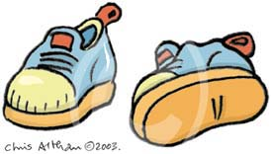
4 large glue sticks
1 regular white Elmer’s glue
2 boxes crayons---regular 24 count
3-4 regular size pencils---not jumbo
1 large box Crayola washable markers---8 count
1 pair Fiskar scissors ---the others do not cut well
1 pack dry erase markers
4 containers regular size Play-Doh
2 containers Clorox wipes
3 boxes snack size baggies (100 count)
3 rolls of paper towels
2 boxes of tissues
2 boxes of baby wipes
1 liquid hand soap (Girls)
1 bottle hand sanitizer (Boys)
1 Red 3 prong folder

- Each student will need a complete change of clothing to be kept in the backpacks at all times
- Full day students will need a cloth nap mat
- Please label all school supplies

